مكونات الكتالوج المرافق للمظلاة
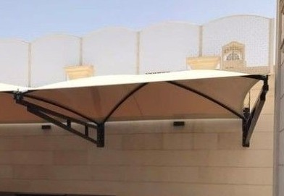
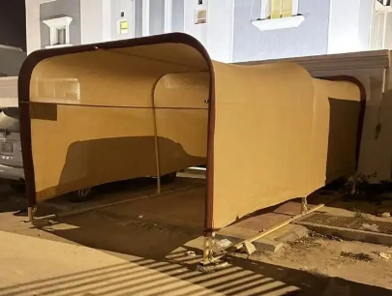
التصميم
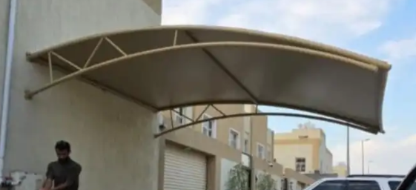
Code : ATL-3
Code Size1: ATL-3S
FIX TYPE : Hanging ATL-3S-H
Column ATL-3S-C
Code Size2: ATL-3B
FIX TYPE : Hanging ATL-3B-H
Column ATL-3B-C
Code : ATL-2
Code Size1: ATL-2S
FIX TYPE : Hanging ATL-2S-H
Column ATL-2S-C
Code Size2: ATL-2B
FIX TYPE : Hanging ATL-2B-H
Column ATL-2B-C
Code : ATL-1
Code Size1: ATL-1S
Code Size2: ATL-1B

المقاسات القياسية
Code | P Code | الارتفاع | الطول | العرض
ATL-1 | ATL-1S mean small | 2300mm | 5800mm | 3500mm
 | ATL-1B | 2400mm | 5800mm | 6000mm
ATL-2 | ATL-2S-H | 2300mm | 5000mm | 3000mm
 | ATL-2S-C | 2300mm | 5000mm | 3000mm
 | ATL-2B-H | 2300mm | 10000mm | 3000mm
 | ATL-2B-C | 2300mm | 10000mm | 3000mm
ATL-3 | ATL-3S-H | 2300mm | 5000mm | 3000mm
 | ATL-3S-C | 2300mm | 5000mm | 3000mm
 | ATL-3B-H | 2300mm | 10000mm | 3000mm
 | ATL-3B-C | 2300mm | 10000mm | 3000mm

